Notes from Stock Holding Study Day for JAC Users
London and East of England

This document augments the stock control toolkit for JAC previously circulated.

Stock Holding Locations

- Types of Stock Holding Locations
Locations are designated as ordering locations or requisitioning locations. Each ordering location will have a different order prefix (e.g. S or SP).
- The Order Matrix
The order matrix defines the type of location and will be specific to your trust. This defines the logistics channels within stock holding locations within the trust and in what order they are accessed. E.g.
  - Requisitioning locations will requisition stock from the designated location so long as it is stored there (even if there is no stock).
  - Ordering locations will order stock from designated supplier.
NB. If a product is no longer required to be stocked at a location it is imperative it is deleted from that location. Otherwise JAC will continue to try and requisition from the location (according to the matrix) even if no stock is there and the minimums have been removed.

Be aware that the ordering matrix is further (further) complicated by the trading matrix which is used for manufacturing and trading goods. Probably best to take advice if this is in use on some locations and perhaps get your head around the trading matrix first!
JAC can provide you with a map of your current order matrix. It is important to ensure that your order matrix optimises your stock control. Compare it against what would be sensible. Does it need changing? If it does talk to JAC.
- DDNR, DD, and REQ Considerations
These considerations can be used to override the order matrix (if required) by adding to an item file. They work in the following way.
DD is the more powerful consideration. If this is attached to a drug file the order matrix is overruled at all times and an order will always be raised to satisfy the demand for stock as long as the location is set up for ordering within the order matrix. This covers all pack sizes.
DDNR acts in a similar way but will requisition the item if it is stocked in the location it obtains requisitions from. If it is not then an order will be raised as long as the location is set up for ordering within the order matrix. JAC advice is to have this consideration as a default on most drug files.
REQ stops ordering for this item and forces a requisition.
If a pack is designated as an ingredient for a manufacturing process this may override any of these indications. If they don’t seem to work consider this.

- Merging Stock Holding Locations
It is good stock control policy to minimise the locations you have holding stock. Using XFR and XFR2 it is possible to merge stock shelf locations automatically. There is a charge for the use of this programme. Contact JAC for details.
NB Robots are often mistakenly considered as a stock location. They are shelves on JAC not a location.

Stock Holding
- SHOLD
SHOLD provides three types of suppliers (although more would be useful). The titles should be disregarded (consider them as S1 S2 and S3). This allows you to set up three types of suppliers with different levels of stock holding. You should choose the best way to use these three types of suppliers to best categorise your stock. (e.g. S1set at 7 days for wholesalers, S2 at 14 days for direct supply and S3 at 28 days for suppliers with poor supply performance (or a shorter time for bulky items that you don’t have room for).
NB You can categorise stock holding parameters for different types of stock by holding them in a different location (e.g. if you had a location called bulk store you could hold different days stock holding for that stock held there).
- Stock Holding Days
There was considerable variety in the figures people use. Typically wholesalers were set at 7 days with direct supply between 14 to 28 days. NB the number of days should not be taken literally. Really this number is just a factor. The larger the factor the more stock you will hold. You need to adjust SHOLD and measure what this does to your stock turn, your stock holding figure AND your supply performance (number of to follows) to get the optimum figure.
- RATIOS
JAC calculates a daily usage figure by looking at the last 3 months worth of data. NB the current month is ignored until after day 6. After day 6 the months usage is extrapolated from the data existing for that month (e.g. if 14 days worth of data is present the figure would be doubled).
The weightings given to the various months can be changed using RATIOS. The weighting (in percent) of each month can be set. Thus if all the weighting (100%) is applied to the most recent month the other two months will be ignored and the volumes ordered will depend entirely on the most recent data. Normal ratios would be 50% for current month, 30% for previous and 20% for earliest.
RATIOS can be set for all products or more usefully for individual. Thus a new item could have its ratios set for 0,0,100 or else any usage will be downgraded by the previous low use. [NB another way to manage this is to set the minimum for the first three months]. Similarly a more responsive pattern would be needed if a formulary change had just been made for example. These individual changes need to be managed and changed as data on new use accumulates. You can track any individual changes using RATIOSL.
- Lead Times
This is calculated as an average for orders from the last time it has been changed. JAC uses the lead time to calculate the minimums for individual drug lines. It was noted that lead times can be distorted if you create dummy orders (i.e. for stock sent in error you want to keep) as the lead time for these could be a few minutes rather than the normal time. This would be especially apparent if the lead time had just been manually set. You can reset the lead time in SMAINT.
NB If you change a lead time manually this changes all the previous entries to that changed value and ALL the previous entries are then subsequently used in the calculation (e.g. if you had 9 entries at 10 days which you changed to 20 days and the next came in at 10, the lead time would be 9x20+1x10 divided by 10). Thus it is not a good idea to manually change lead times unless circumstances have changed.
- Minimums
JAC orders when stock reaches or crosses the minimum. [NB if you cancel an order the system won’t raise another order unless there are more issues. So if the minimum is 0 some trusts find the system won’t order a drug after it has been cancelled (as there is now no stock to issue and trigger an order)]. Minimums can be fixed or unfixed. If they are fixed they will never respond to changes in usage. You can view which are fixed on the midnight processor report AND what the system thinks it should be using DMIN. This report should be run regularly and any major differences investigated. A minimum of 0 is still active and an order will be created when stock levels reach 0. If the entry is null then no order will be created automatically. You can set a minimum to order on dose units in DMAINT by checking DF and adding the dose units (e.g. half a pack).
NB
  - In general it is important to use KADJ and KTRANS as little as possible. This is because they do not count in calculating usage and will not contribute to a change in minimums etc. So if they are used a lot the minimums will remain too low. You can run a Crystal report to check on use of KADJ and KTRANS and who is doing it!).
  - Fix a minimum at 0 if it is a high cost item which you use infrequently and get from a wholesaler. Then it will always order but only when stock runs out.
  - To limit the stock held apply an artificially short shelf life to the product (in DMAINT). This will prevent the system ordering too much stock.
  - Or fix a minimum and a maximum with a difference of one pack. This will maintain stock at a level (the minimum) but not order more than one pack. Useful for items where you want to limit the max but still hold a reasonable amount of stock (e.g. Mannitol infusion).
- Maximums
The maximum limits the top extent of the minimum and to some extent the order quantity. How it works is complex and JAC will sometimes order more than the maximum but it will prevent large orders. Again treat the maximum as a factor and experiment until you get the required effect. A rule of thumb is to assume that ignoring to follows the maximum will be the maximum = minimum values. [NB see note c) above for an alternative way to limit the size of orders].
- OMID
OMID theoretically reduces the number of orders raised by consolidating order lines. It considers all lines from a supplier and “tops up” the order to make them reach the proper stock holding. Probably half users use OMID and half don’t. It is a way of forcing orders off the system as OMID ignores minimums. NB OMID also ignores maximums so may cause difficulties for bulky products. You probably should use it monthly and selectively, particularly for suppliers with predictable demand and those with a minimum order value. Suppliers with a large number of items could have half the items ordered on week 2 and half the others on week 4. You could separate the types of items into fridge or bulk for example. This allows for the inevitable small unexpected orders for those items already process by OMID which would otherwise be difficult to manage if they arise just after an order has been sent. They can be added to the next scheduled order.
NB See Appendix 1 for a method of calculating how often to run OMID.
- The JAC Algorithm
This is well covered in the toolkit. The algorithm rounds up to the nearest outer of discount threshold figure. To follows are also added no matter what type (e.g. if t/f is on a dispensed item which has forced a t/f on a requisition this will count double).
It is possible to limit the number of orders by fixing the outer pack size artificially high. The system will then order a lot of stock (in the outer you have specified) but less often.

To Follows
These can be switched on or off and are taken into account in calculating the order volumes (they will raise them). If they are switched on to follows need to be actively managed. Run TFCHECK to see which orders are being affected. To follows need to be deleted unless they are genuine (i.e. the stock will be sent to the requestor once it arrives). Most participants use to follows for bulk issues.
NB you can use the number of to follows (or even the number of pages) as a proxy measure of supply performance (and hence a measure of how good you are at holding stock).

Slow Moving Stock
This report (KSLOW) should be run 2-4 times a year to identify stock unlikely to be used.
Preferential Suppliers
It is possible to select preferential suppliers for different stock locations (e.g. location 1 orders direct whereas location 2 orders from a wholesaler). This can be useful but if you use this be careful when making contract changes as the preferential supplier will still operate unless you cancel it.

Dealing with Contract Changes
This has been made a lot easier by the facility to enter contract changes in advance and specify the date they will become live. NB supplier preferences still have to be adjusted on the day.Most trusts decouple their EDI links (either using the CMU decoupler or manually) and then rematch links s the orders come up. This is quicker.
How to Deal with Free Stock
Most people ORMAINT the order after sending it. The new order quantity should be that of the order plus the free stock. This can then be invoice matched to the invoice for the paid stock but will be attributed to the complete order.
For free stock on PAS schemes the stock is actually free so most people create a second drug file for the free stock.
Returning Stock
Returning stock is the biggest cause of dose units being introduced onto the system. KUPAR can be used to “unpart pack” a pack but it has limitations.

Coping with Compensation Payments after Buying Off Contract
The group to solve this!

Homecare
See separate sheet. Not all goes through the pharmacy system but ideally it should.
Most have separate drug files for homecare drugs (e.g. Etanercept (homecare). Some also have separate locations for “holding” homecare stock. This prevents dispensary staff issuing against the wrong drug file.
[NB JAC now have a homecare module (for sale) which facilitates electronic transmission of orders and invoices].

There are two standard methods
- Rx written and screened in dispensary.
- Clerk raises order from Rx (1 per patient) and send to homecare provider.
- Delivery note and invoice received from provider and ODELIV’d , DISP’d and invoice matched in one.
- A separate drug file(s) is used for homecare costs (delivery etc). These can be added to the invoice to pay for charges.

- Invoice is used to raise an order and then proceed as 3. above.

Robot Tips
- A common problem is when staff book out dose units on the JAC system but take out packs from the robot. If possible only issue stock as packs.
- KROB shows discrepancies between the robot and JAC (although this is limited by the use of the correct EAN. If multiple packs with different EANs (as in a shortage) are used the robot can’t cope). Trusts run this weekly but only after the stock has been placed in the robot ☺
- Some trusts allocate 30 mins at the start of the day to sort out EAN mismatches in the robot.
- It is possible to ODELIV via the robot for ARx machines. You have to purchase this module from JAC and segregate each order.

The Daily Routine
Most people worked in the following way

- View OIMAINT on line as it is quicker than OILISIT although it doesn’t give so much information. If you need the greater amount of information from OILIST then open that and look at the specific line.
- Orders are released. Some release all orders raised so they can relate to the order number and release date. Many trusts have a schedule of companies they send order too. (E.g. send companies every other day). Others leave orders until they are ready to go. Wholesalers are normally left until just before the cut off.
- The to follows list is checked.
- Any problems and shortages with orders are then dealt with (e.g. alternative suppliers used etc.)
- Use the CMU on line catalogue for all contract queries and issues. If necessary use PharmaQC to view PQA scores for alternaives if a contract line is out of stock.
- Once a week run OSNI. This shows the items on the shelf which have not been invoiced.
- Once a month run ONOTI. NB this is often huge but is good to run just before end of financial year.

Kevan Wind 22.1.2014.

Appendix 1
Khurram Shaghzad from Croyden uses the following technique for deciding how often to run his OMID orders on the system.

Steps to Extract Ordering and Invoicing Data for Individual Suppliers From JAC Base Tablets
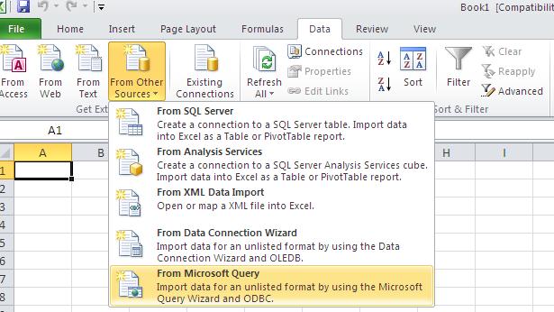
1) Open Microsoft Excel and go to “Data” Tab.
2) Click on “From Other Sources”
3) Click on “From Microsoft Query”
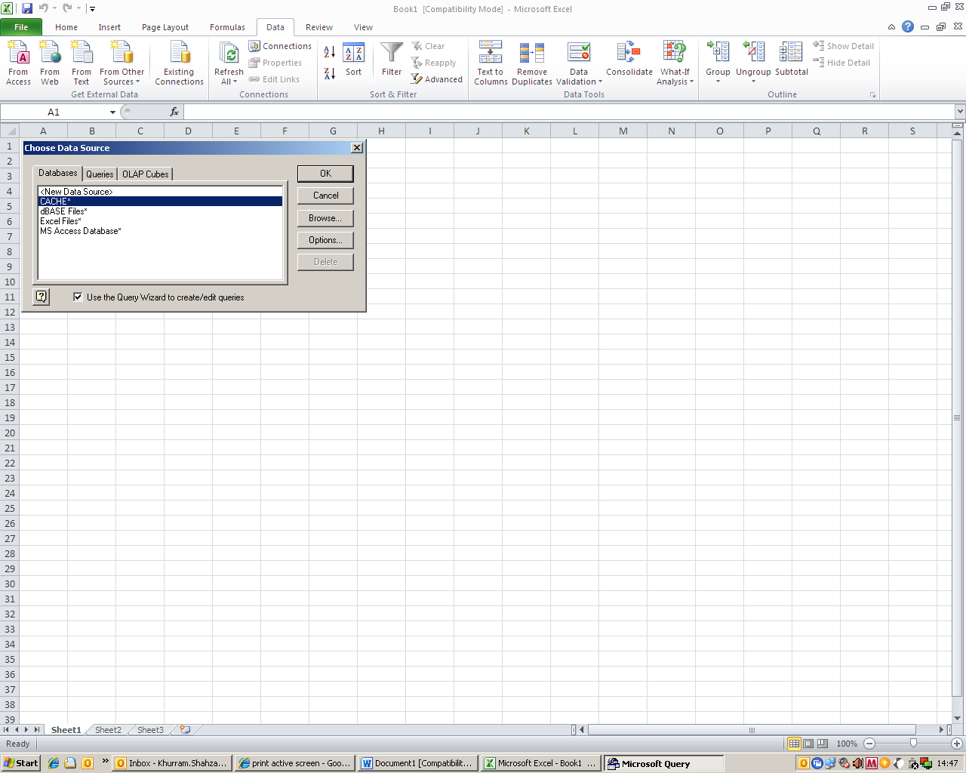
4) As shown in the picture, “Choose data source” window will appear. Select the “CACHE*” option and click OK.

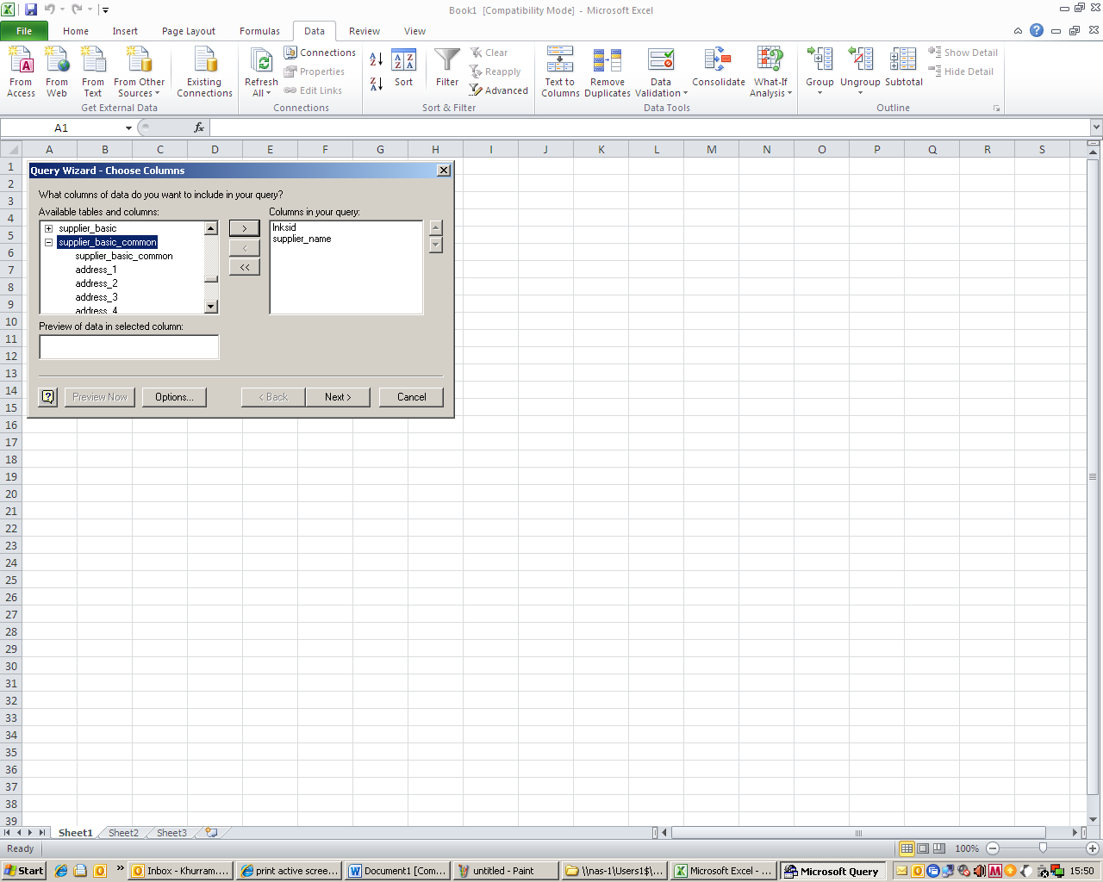
5)Once the “Query wizard” window pop up, scroll down to the base table for “supplier_basic_common” and click on the + sign.
6) A lsit of all the sub columns will appear as shown. Click on “Inksid” and “supplier_name” respectively and add to the “Columns in your query” section by pressing “ >” button.

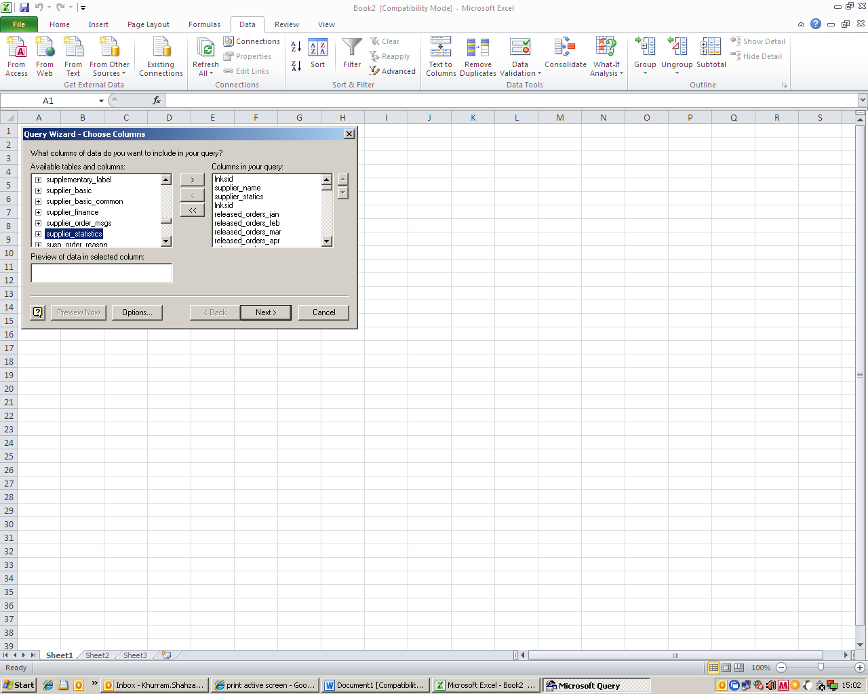
7) Now go the “supplier_statistics” column which is few rows down and just click on the main column. (Do not click on + sign. Click on “ >” button and all the sub-columns for this will be added to the query. Then keep pressing the “NEXT>” button.
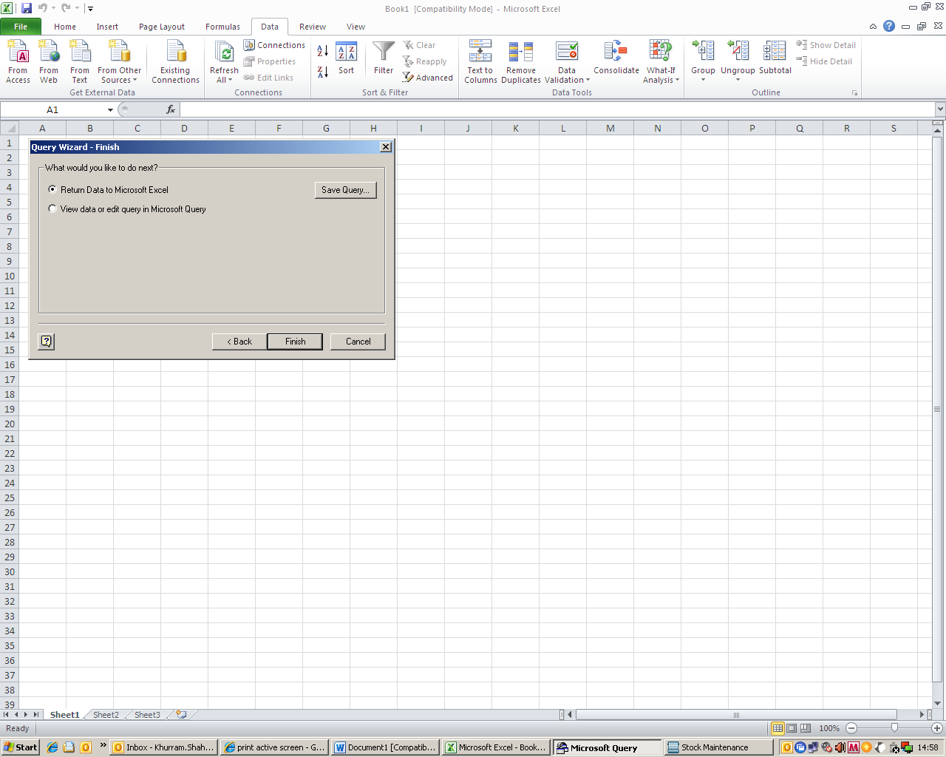
8) Once you see this window, press the finish button to complete the query.

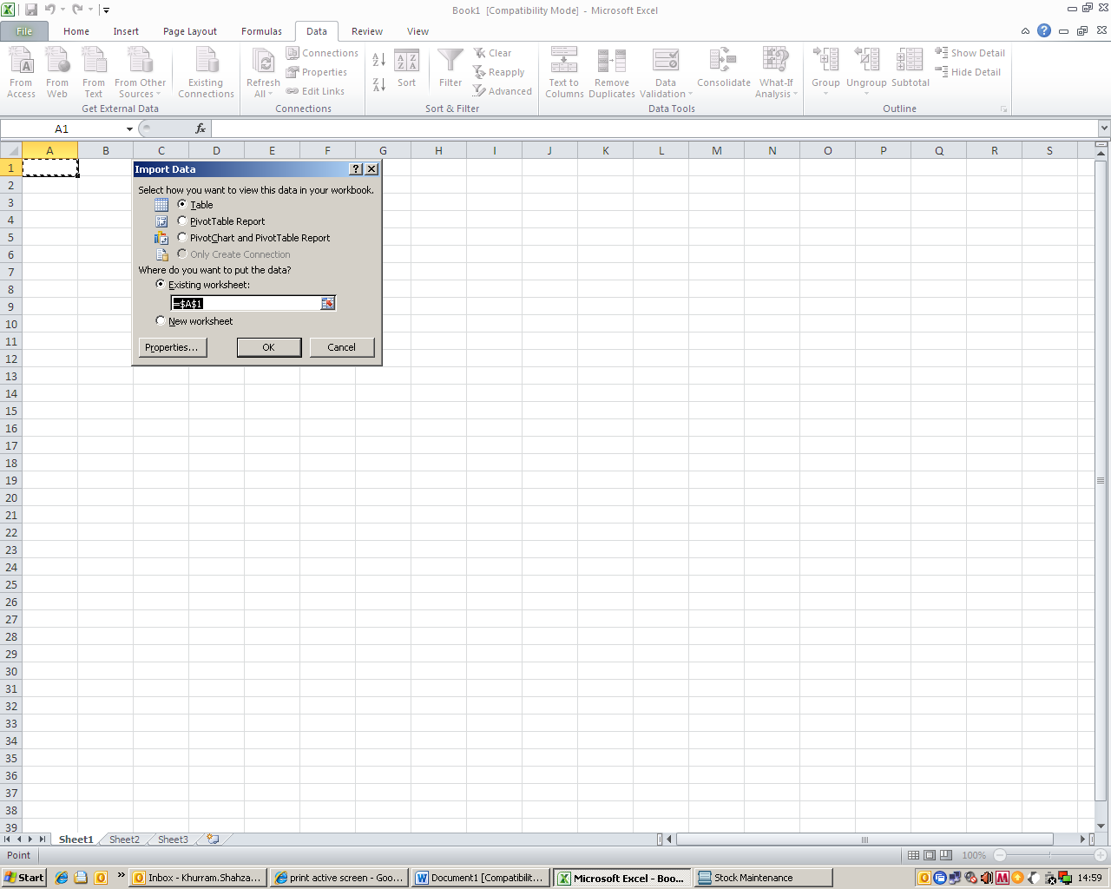
9) After the previous step, this window will appear. You can select form the given options for more advanced options, but the default option would be “Table”. Click OK to run the report.

Once all the above mentioned steps are performed the following data report will appear for all your suppliers. Now you can manipulate the data and delete or edit the columns in order to get some meaningful information in order to evaluate the number of orders and items for each supplier per month, which can help you to decide what OMID frequencies you can choose for your top suppliers. It also helps you identify your current ordering patterns for the suppliers.

